**Program requirements:**

A program that reads a set of a paragraph of 6 sentences from a file into memory. It prints the sentences on the console printer. It then asks the user for a word. It searches the paragraph to see if it contains the word. If so, it prints out the word, the sentence number, and the word number in the sentence.

**Detailed Design**

1.It reads 6 sentences from a file into memory

1. using ‘IN’ instruction to read
2. every sentence end with a period ‘.’
3. end when get the sixth ‘.’

2. prints the sentences on the console printer.

1. using ‘OUT’ instruction to print

3.It then asks the user for a word.

1. using ‘IN’ instruction to read
2. end when get ‘\0’

4.searches the paragraph to see if it contains the word.

5.print the word, the sentence number, and the word number

1. using ‘OUT’ to print the result
2. using space ‘ ‘ to separate the three elements.

**Searching Algorithm**

var x3 = addr[para]

var x2 = addr[word]

var start = x3

var word = 1

var sentence = 1

var found = 0

L1a:

if mem[x3] != mem[x2]: goto L1B

x2++

x3++

if mem[x2] != '\0' :goto L1a

found = 1

goto end

L1B x2 = addr[word]

if mem[x3] != ' ': goto L1C

x3 += 1

word += 1

goto L1a

L1C: if mem[x3] != '.': goto L1D

x3 += 2

word = 0

sentence++

goto L1a

L1D: x3++

goto L1B

end:

**Memory Map**

|  |  |  |
| --- | --- | --- |
| Start Address | End Address | Comments |
| 6 | 6 | zero |
| 7 | 7 | . |
| 8 | 30 | temp memory |
| 31 | 40 | input word to search |
| 256 | 511 | code |
| 512 | 1024 | input string |

**Examples:**

**Step1:**

Input the program code into the input-text area, then click “compile”, set the mem-text filed as “256”, then click “Load_I”, such that we store the source code in the memory position 256.

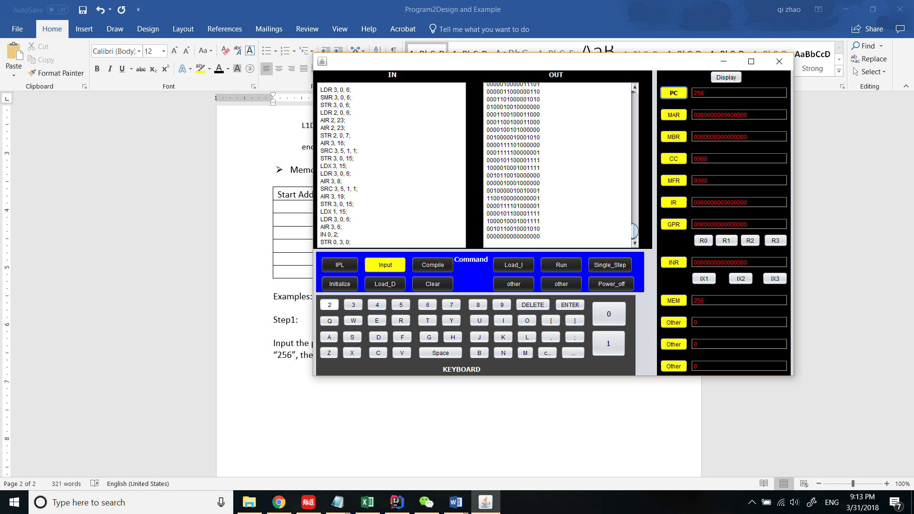

**Step 2:**

Click “clear” to clear the contents in the text-area. And set the PC-text filed as 256. Then copy a six-sentences paragraph to the input text area. Click “run”, such that these sentences are stored in the memory and appear in the output-text area.

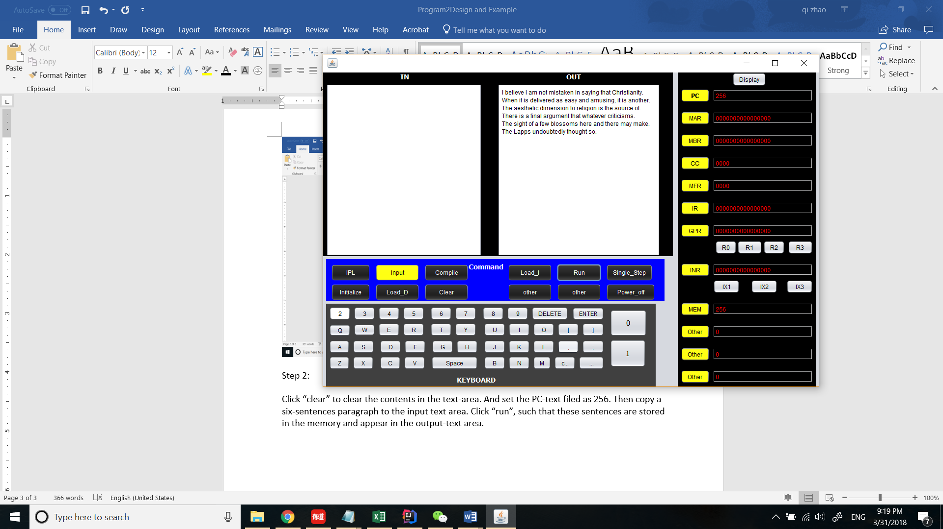

**Step 3:**

Input the query- word in the input-text field, then click “Run”, and the word, the line number and word number will appear below the sentences in the output-text area.

***Input “final” , the result is “final 4 4”***

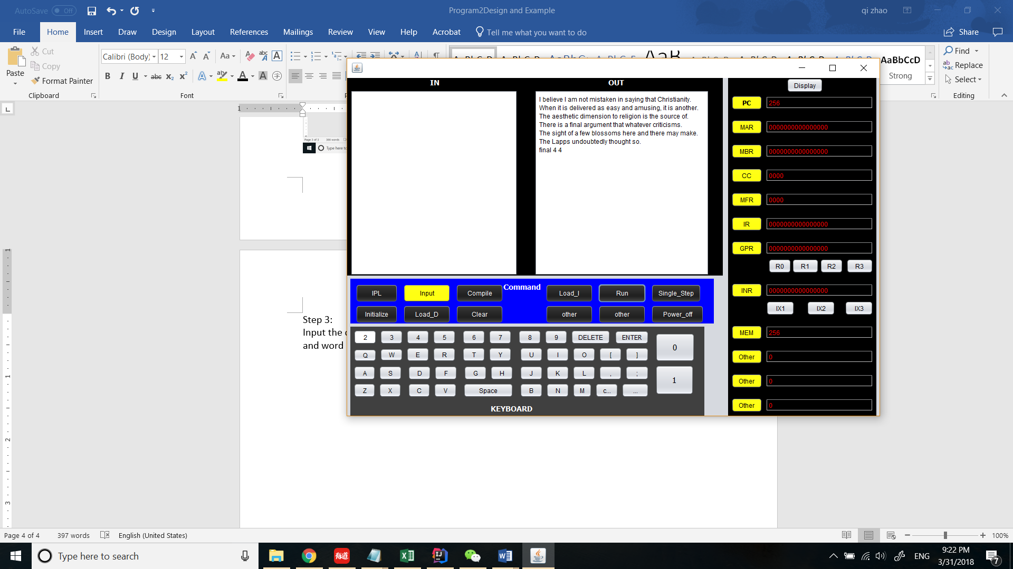

You can try for many times. For the second time you try, just reset the PC to “256”, and then copy the sentences to the In-text area, the follow steps are same as former.

***Input “here” , the result is “here 5 7”***

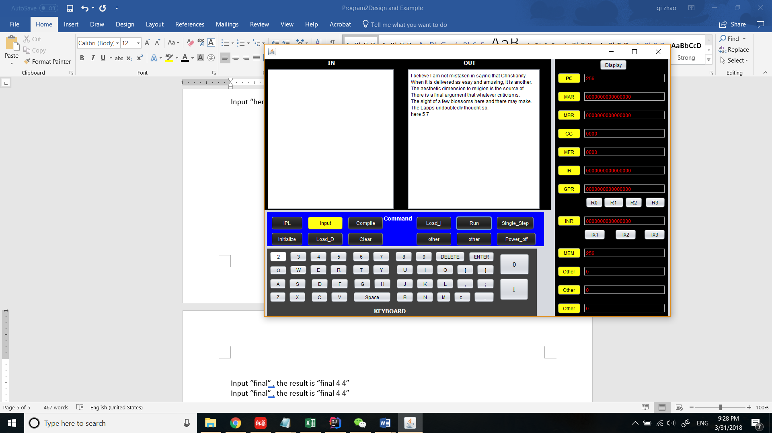

***Input “easy”, the result is “easy 2 6”***

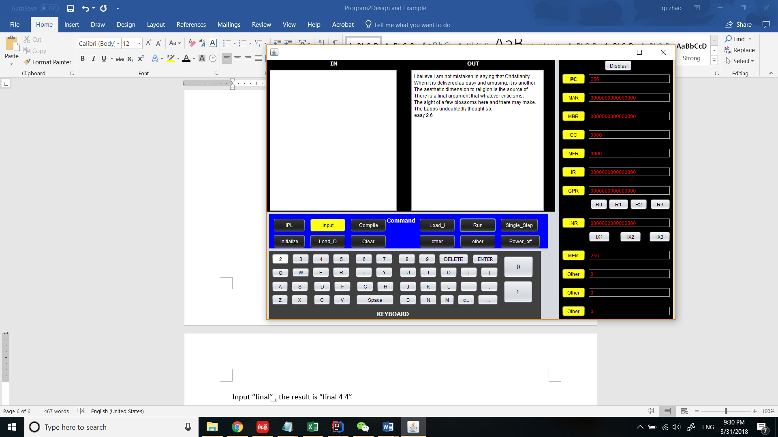

***Input “Lapps”, the result is “Lapps 6 2”***

